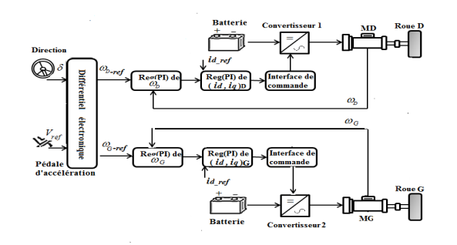
http://dspace1.univ-tlemcen.dz/bitstream/112/13696/1/Doct.Aut.BENARIBA.pdf

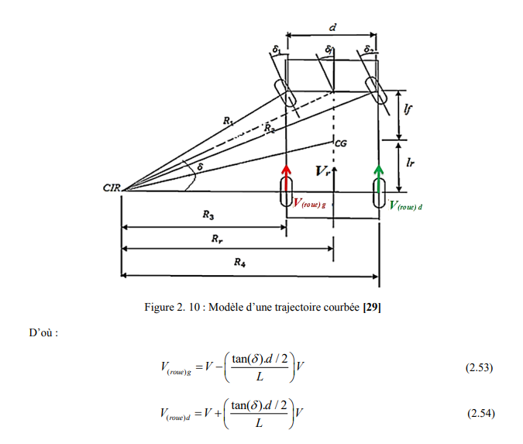

https://www.youtube.com/watch?v=qXoCHETmJ0k

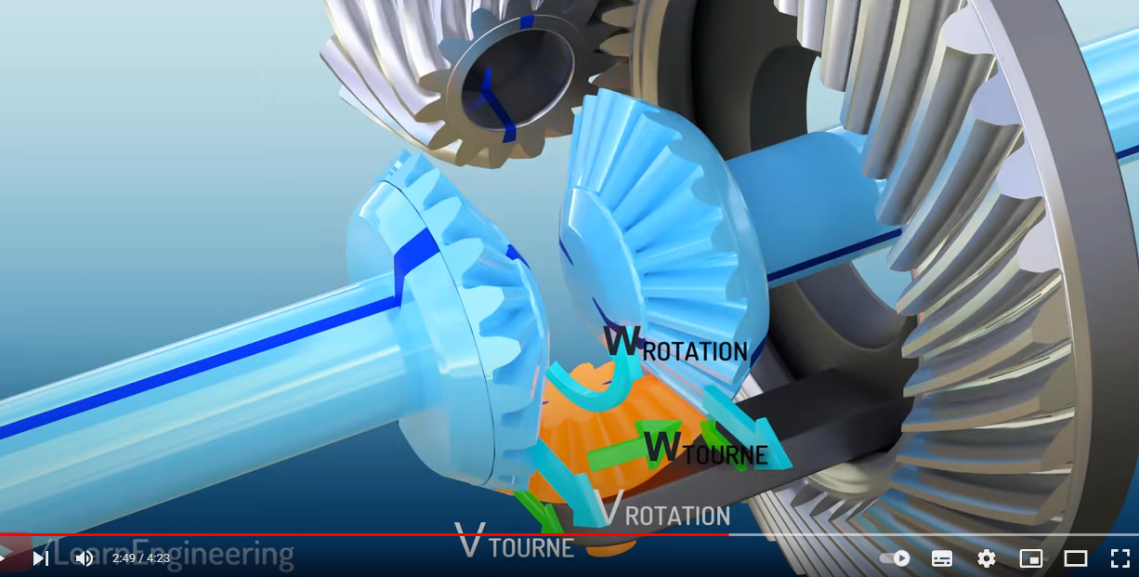

https://ieeexplore.ieee.org/stamp/stamp.jsp?tp=&arnumber=7084489
Electronic Differential for Electric Vehicle With Single Wheel Reference

https://ieeexplore.ieee.org/stamp/stamp.jsp?tp=&arnumber=6152168
Design and Evaluation on Electric Differentials for Overactuated Electric Ground Vehicles With Four Independent In-Wheel Motors

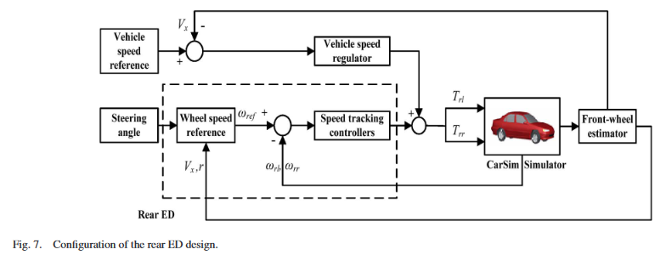

https://ieeexplore.ieee.org/stamp/stamp.jsp?tp=&arnumber=4739021
Design of Electric Differential System for an Electric Vehicle with Dual Wheel Motors

https://ieeexplore.ieee.org/stamp/stamp.jsp?tp=&arnumber=6671654
A Fault-Tolerant Electronic Differential System of Electric Vehicles

https://citeseerx.ist.psu.edu/document?repid=rep1&type=pdf&doi=4412ea7a55e35b4dea623e17b63246c42700812d
ROBUST ELECTRONIC DIFFERENTIAL CONTROLLER FOR AN ELECTRIC VEHICLE

https://journals.tubitak.gov.tr/cgi/viewcontent.cgi?article=3536&context=elektrik
Electronic Diff onic Differential with Dir ential with Direct Torque Fuzzy Contr uzzy Control for V ol for Vehicle Propulsion System
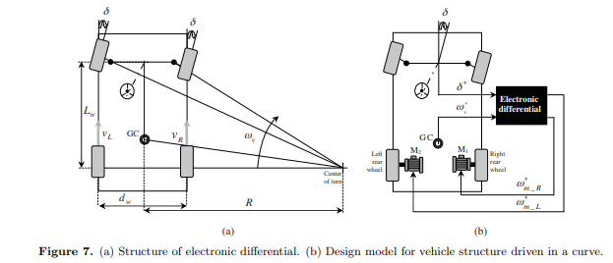

https://ieeexplore.ieee.org/stamp/stamp.jsp?tp=&arnumber=4239230
Traction Control based on Slip Ratio Estimation Without Detecting Vehicle Speed for Electric Vehicle
Un joyeux bazar à comprendre j’ai l’impression

https://ieeexplore.ieee.org/stamp/stamp.jsp?tp=&arnumber=1223415
Yaw Moment Control via Emotional Adaptive Neuro-Fuzzy Controller for Independent Rear Wheel Drives of an Electric Vehicle
boss final du game (réseau de neurones)

https://ieeexplore.ieee.org/stamp/stamp.jsp?tp=&arnumber=8998097
SCALE DOWN MODEL OF ELECTRICAL VEHICLE USING ELECTRONIC DIFFERENTIAL

https://shura.shu.ac.uk/30090/1/Lenzo-RevisitingMechanicalLimited-slip%28VoR%29.pdf

https://link.springer.com/chapter/10.1007/978-3-642-24145-1_23
Direct Torque Control for Electronic Differential in an Electric Racing Car

https://www.tandfonline.com/doi/epdf/10.1080/13873950500066959?needAccess=true
Detailed and reduced dynamic models of passive and active limited-slip car differentials

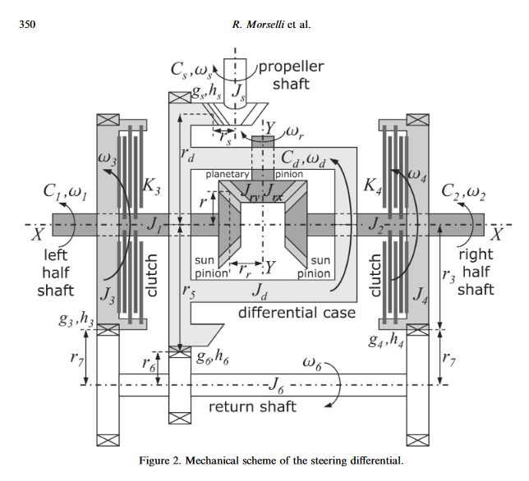
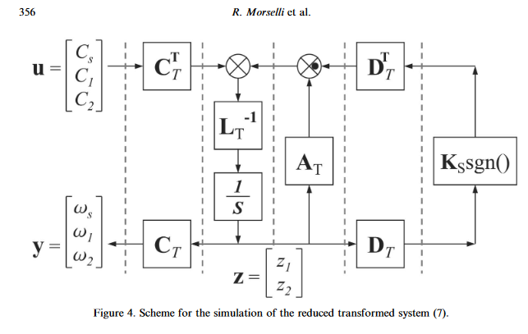

https://www-techniques-ingenieur-fr.ec-lyon.idm.oclc.org/base-documentaire/mecanique-th7/transmission-de-puissance-mecanique-engrenages-et-liens-souples-42182210/boites-de-vitesses-le-differentiel-bm5664/etude-theorique-bm5664niv10002.html
Boîtes de vitesses. Le différentiel

https://ieeexplore.ieee.org/stamp/stamp.jsp?tp=&arnumber=7520599
Electric Differential Control for Electric Vehicles Based on EMD Method

https://ieeexplore.ieee.org/stamp/stamp.jsp?tp=&arnumber=5498381
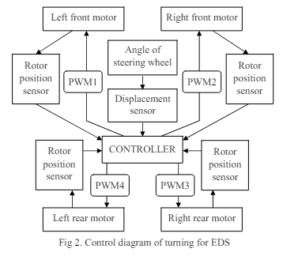
The Control Strategy of Electronic Differential for EV with Four In-wheel Motors
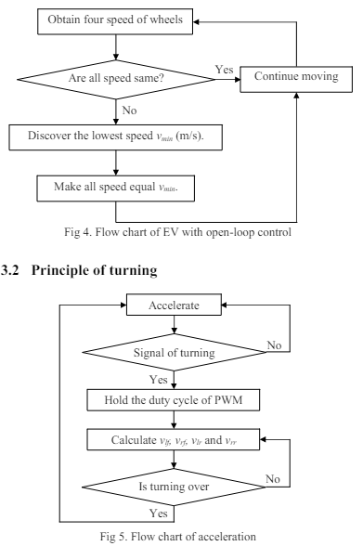

https://ieeexplore.ieee.org/stamp/stamp.jsp?tp=&arnumber=8937199
Modeling and Simulation of Independent Speed Steering Control for Front In-wheel in EV Using BLDC Motor in MATLAB GUI
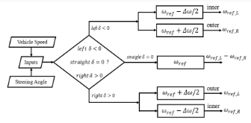

https://ieeexplore.ieee.org/stamp/stamp.jsp?tp=&arnumber=6563667
Differential Speed Steering Control for Four-Wheel Independent Driving Electric Vehicle

https://ieeexplore.ieee.org/stamp/stamp.jsp?tp=&arnumber=7459238
Design of Electronic Differential System for An Electric Vehicle with In-Wheel Motor

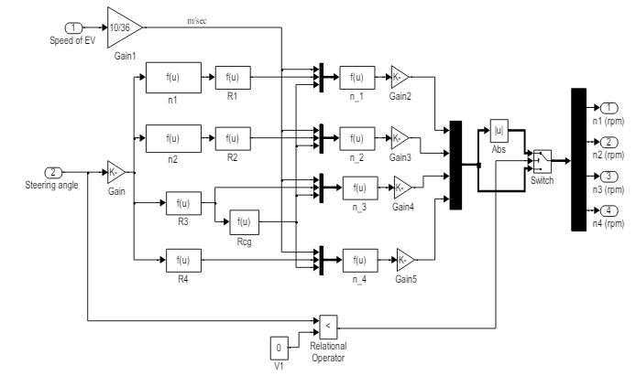

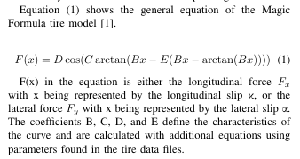
https://ieeexplore.ieee.org/stamp/stamp.jsp?tp=&arnumber=9071136 | Pacejka Magic Formula Tire Model Parser

https://hal.science/hal-00673999/document

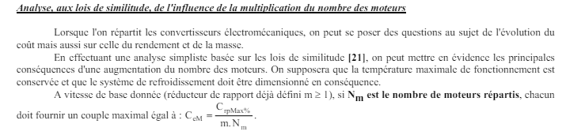
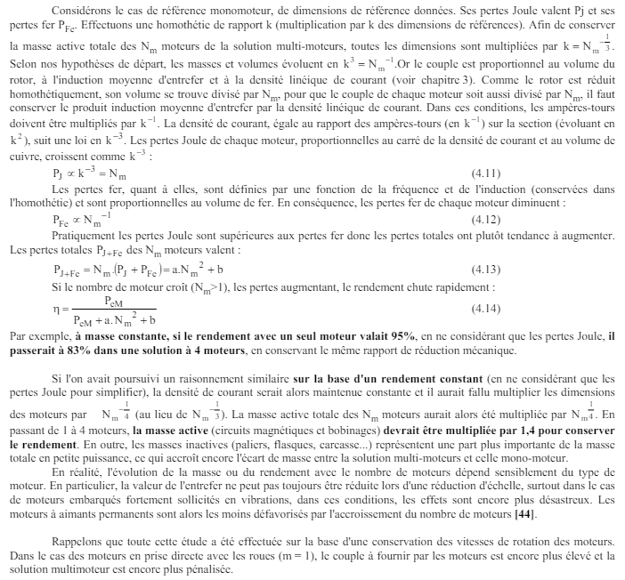
http://dspace.univ-tlemcen.dz/bitstream/112/15026/1/Ms.Aut.Marif%2BAbdat.pdf
La commande en vitesse d’un véhicule électrique
Pas mal sauf le modèle dynamique du véhicule (virage notamment)

https://ieeexplore.ieee.org/stamp/stamp.jsp?tp=&arnumber=9661256
Electronic Differential Control for Distributed Electric Vehicles Based on Optimum Ackermann Steering Model

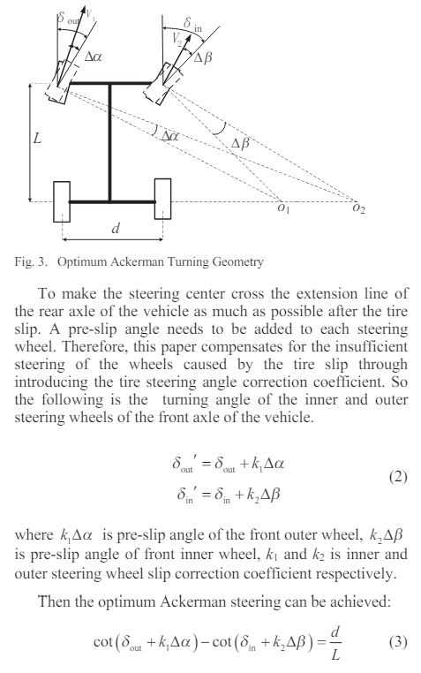
Correcteur PID dont les coefficients varient (calcul en live par un réseau de neurones) et modélisation basée sur Ackermann

https://ieeexplore.ieee.org/stamp/stamp.jsp?tp=&arnumber=6419924
Yaw Torque Control of Electric Vehicle Stability

https://ieeexplore.ieee.org/stamp/stamp.jsp?tp=&arnumber=7394567
Electronic Differential System for an Electric Vehicle with In-Wheel Motor

https://books.google.fr/books?hl=fr&lr=&id=eoy19aWAjBgC&oi=fnd&pg=PR7&dq=electric+vehicle+dynamics&ots=8y7QcgR69d&sig=BwKRQQ-UApqUFZUlwdyG4ITp818&redir_esc=y#v=onepage&q&f=false
Vehicle dynamics and control

Lateral vehicle dynamics p15
Longitudinal vehicle dynamics p87
Suspension
Tires forces p355

http://www.ingveh.ulg.ac.be/uploads/education/MECA0525/notes/MECA0525.pdf
PERFORMANCE ET DYNAMIQUE DES VEHICULES
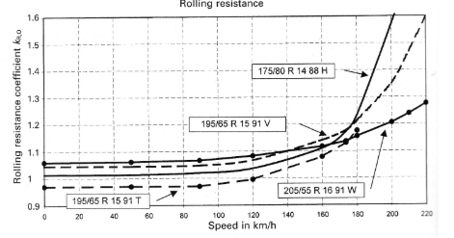

p113-115

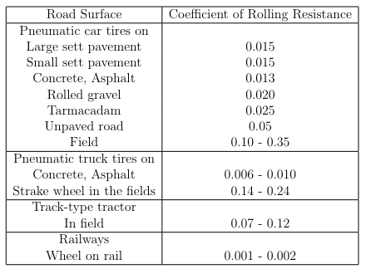

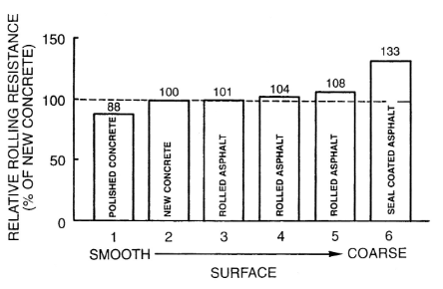

p149 pour un détail sur Pacejka
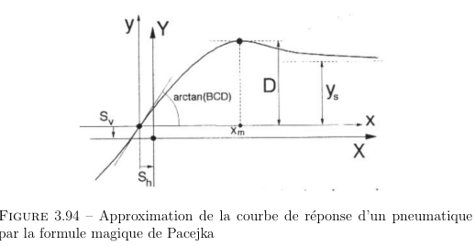

→ Sûrement une expérience à faire sur les pneus pour avoir les bons paramètres du modèle

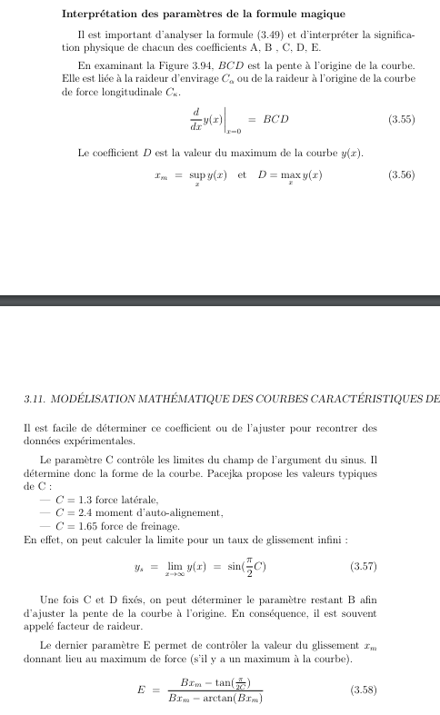

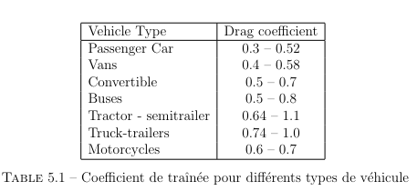

https://www.edy.es/dev/docs/pacejka-94-parameters-explained-a-comprehensive-guide/

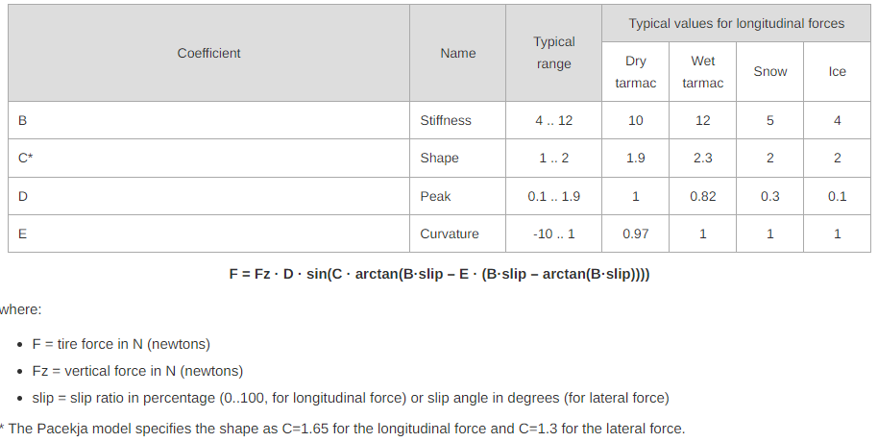
https://docs.arduino.cc/tutorials/nano-motor-carrier/nano-simulink-wifi-led/
tuto utilisation arduino avec Simulink
https://fr.mathworks.com/help/simulink/supportpkg/arduino_ug/wifi_udp_connection_connectedio.html
idem

ODG
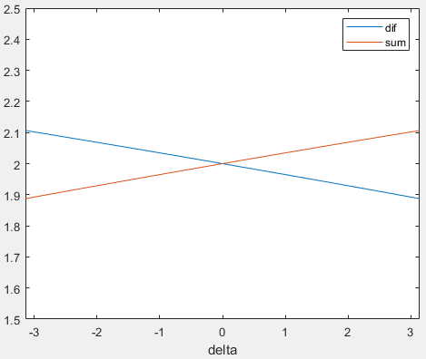

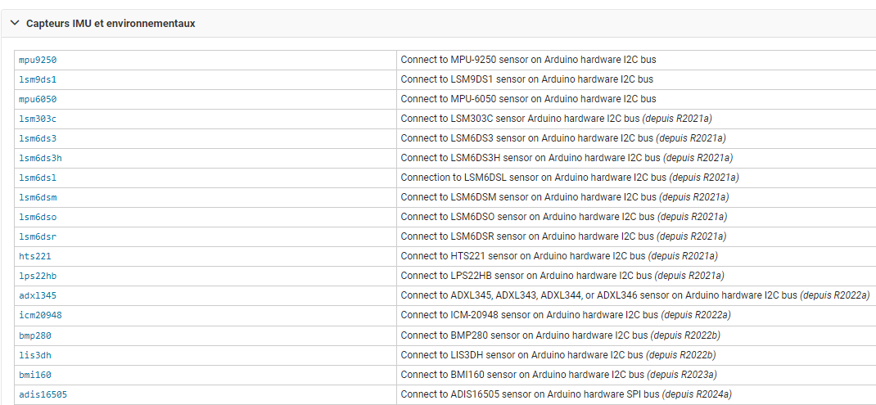
Capteurs IMU compatibles avec Matlab

Cartes Arduino compatibles avec Matlab

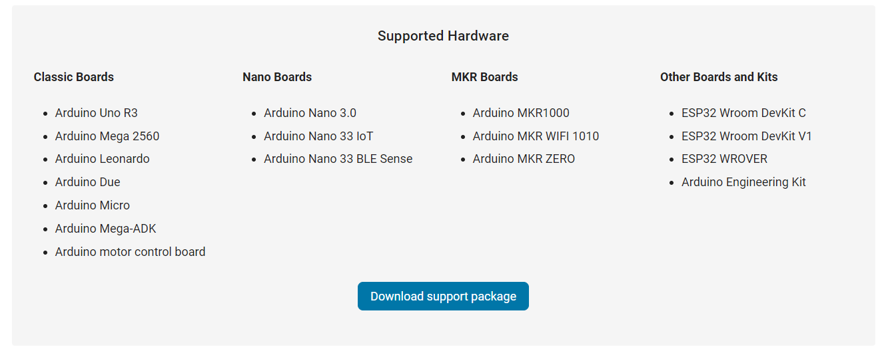

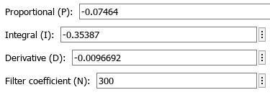
Tuning PID premier jet

